OpportunityOS: An Agentic AI Framework for Automated Problem Discovery and Product Opportunity Identification from Large-Scale User Signals

Abstract
In contrast to historical patterns of constraint in product development, the bottleneck has been flipped. For most of our past, the problem has been how difficult it is to build something valuable; now with the advent of foundation models, elastic clouds, and open-source ecosystems, building is easier than ever before, and the bottleneck has shifted from the problem of how to build to the question of what to build. This is still an issue, however, because the problem of discerning which problems are worth solving has become more difficult due to the noise of digital discourse. This paper proposes the notion of OpportunityOS, a conceptual agentic AI system, that continuously converts a massive number of fragments of signals coming from app reviews, social-media discussion, developer forums, support tickets, and search data into a hierarchy of opportunities for products. We propose the idea of moving from the problem of problem-solving intelligence to problem-discovery intelligence. We formalize the concept of an opportunity-scorer with regard to six aspects and put forward an evaluation framework based on discovery accuracy, lead-time, and expert consensus. Our structured literature review of fifty articles, mostly published by Springer, places the design within the realm of sentiment analysis, requirements mining, corporate foresighting, agential artificial intelligence, and entrepreneurship. We outline implications, limitations, and ethics associated with the work and conclude that automated problem discovery is an immense field ripe for artificial intelligence.
Keywords: Problem discovery · Agentic AI · Large language models · Product-opportunity identification · Aspect-based sentiment analysis · Weak-signal detection

1 Introduction
Throughout most of human history, the pace of progress has been constrained by the limits of construction. This constraint has ceased to matter. The era of powerful foundation models, plentiful compute, open source ecosystems and intelligent development tools is one where a small team can launch in weeks what would take an organization months before. When construction gets cheap, the rare and valuable act is discernment: choosing which problems are worth solving. This is the inversion of scarcity that motivates the present work (Fig. 1).
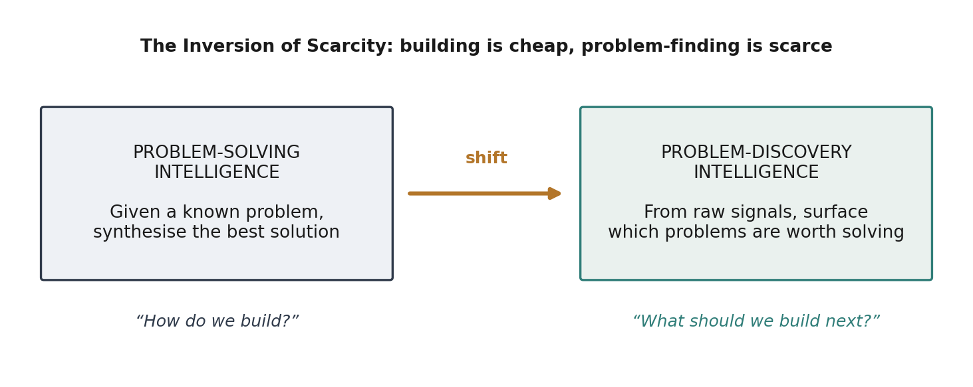
Fig. 1 The inversion of scarcity and the resulting shift from problem-solving to problem-discovery intelligence.
There are plenty of reasons that show that discernment is currently the bottleneck, not execution. Products still fail, companies still shut down, and organizations continue to spend a lot of time developing features their users didn’t ask for. Experience shows us that businesses get disrupted not because they don’t have enough resources but because they realize the problems that they will face in the future too late [1]. In the case of new ventures, there is a deeper risk because the biggest danger for the company is that they spend many months developing something nobody needs, because revolutionary companies always start from an insightful problem, not from the solution [2]. Schumpeter’s theory about innovation as recombination [3] and the “individual-opportunity nexus” in entrepreneurship literature [4] state that the value creation begins from opportunities, while a meta-analysis of opportunity identification reveals that this field is very fragmented and empirical research is poorly developed, as it is mainly focused on the individual aspects like experience and alertness [5].
Meanwhile, millions of people tell us about all their problems openly every day in reviews, social networks, forums, support systems and search queries. These signals represent the kinds of things that waste their time, the things that are broken, and the things that they want. Yet they are disjointed, messy, and largely invisible, leaving questions that could be answered strategically that is, what frustrations are brewing in silence, what needs are not being addressed, what opportunities are developing right now to go unanswered.
In this paper, we ask whether artificial intelligence has the potential to evolve from solving problems that have already been identified to identifying problems that ought to be solved. Our contribution here is to introduce OpportunityOS, an agentic-AI framework for continuously converting user signals at scale into a ranked inventory of product opportunities. Our contributions are: (i) a conceptual distinction between problem-solving and problem-discovery intelligence, along with a signal-problem-opportunity model; (ii) a five-layer reference architecture comprising existing NLP and agentic techniques in a problem-discovery pipeline; (iii) an opportunity scoring model based on six dimensions; and (iv) an evaluation method and research agenda.

2 Related Work
OpportunityOS draws on five research streams. We review each and then identify the gap that the framework addresses (summarised in Table 1).

2.1 Opinion Mining and Aspect-Based Sentiment Analysis
Opinion mining from user-generated texts has been well-studied. The early works on summarization of customer reviews provided opinion mining at the feature level [6]. Surveys provide a detailed picture of sentiment analysis, which is seen as an important natural language processing task [7]. Aspect-based sentiment analysis (ABSA) advances it by identifying aspects along with their associated sentiments, going from polarity detection to finer targeted analysis [8,9]. Surveys on deep learning based ABSA show the development of approaches from lexicon/rule-based systems to recurrent, attention and graph-neural networks [10,11]. A survey for practical tasks describes aspect extraction, opinion extraction and sentiment classification, along with compound formulations of them [12]. Benchmarking campaigns such as SemEval set the standard for the task and datasets involved [13]. ABSA provides OpportunityOS with the tools to detect reactions to certain things, but, according to the most systematic review yet, the field still focuses heavily on commercial product reviews and very seldom on discovering problems and opportunities [8].

2.2 Mining User Feedback for Requirements and Change
Another concurrent stream uses app-store reviews and social media to direct software evolution. Reviews can be automatically categorized into bug reports, feature requests, and compliments [14,15], while more detailed sentiments show how users feel about individual features [16]. A survey of analysis of app-stores for software engineering is performed here [17], and techniques to find informative reviews for software engineers [18], and there are works on retrieving and analyzing feature requests as well [19,20]. Other recent works process and analyze large numbers of complaints [21], categorize reviews for maintenance and evolution [22], summarize changes requested by users [23], and create ensembles of classifiers [24]; there is even a systematic review of opinion-mining works over app-store reviews [25]. Nevertheless, these techniques optimize already developed products rather than identify latent cross-domain opportunities.

2.3 Weak Signals, Topic Modelling and Corporate Foresight
The field of foresight looks into the ways to spot weak signals that are hard-to-spot early clues [26]. The concept of emerging trends detection has been explored in a survey conducted in relation to textual data mining, and probabilistic topic models such as Latent Dirichlet Allocation represent an unsupervised approach to finding themes in large collections of documents [27]. Business intelligence and analytics literature explores the connection between large scale data and strategic significance [28], and social media analytics emphasizes user-generated content as a strategic asset [29].

2.4 Large Language Models, Agentic AI and Retrieval-Augmented Generation
Transformer architecture [30] and pretrained language models [31–34] revolutionized information extraction by making it few-shot and promptable. Chain-of-thought prompting [35] and reasoning-and-acting agents [36] allow model planning and tool usage. Retreival-augmented generation makes output evidence-grounded and less hallucinated [37,44], and evaluation for such models is being developed [45,46]. A vast literature reviews large-language-model agents and multiagent systems, their planning, memory, and coordination [38–40], including concrete frameworks for collaboration [41,42] and humanlike modeling [43]. OpportunityOS embraces this agentic approach, which allows to extract, verify, cluster and synthesize information, evidence-grounded via retrieval from the market and taxonomy.

2.5 Opportunity Recognition in Entrepreneurship and Innovation
Opportunity identification is considered to be the unique activity of an entrepreneur, involving previous knowledge [47], “dot-connecting” pattern recognition [48], and alertness in the process of market exchange [49]. However, the systematic review of the field reveals its fragmentation and dependence on individual cognition, rather than on method [5]. OpportunityOS redefines opportunity recognition as a computational and continuous process of society-scale signals.

2.6 Research Gap
Each stream provides a component sentiment, requirements, foresight, agents, opportunity theory yet none delivers an end-to-end system that continuously converts heterogeneous user signals into ranked, validated product opportunities. Existing tools optimise known products or study opportunity recognition descriptively; the synthesis of extraction, weak-signal detection and agentic reasoning into a discovery engine is, to our knowledge, unaddressed. Table 1 contrasts representative approaches with OpportunityOS.
Table 1 Representative approaches contrasted with OpportunityOS along five capability axes.
Approach | Cross-source | Weak-signal | Agentic reasoning | Opportunity output
ABSA / opinion mining [8,10] | Limited | No | No | Aspect sentiment
App-review mining [17,22,23] | Partial | No | No | Change requests
Weak-signal foresight [26] | Yes | Yes | No | Trend keywords
LLM multi-agent systems [38,40] | Yes | Partial | Yes | Task-specific
OpportunityOS (this work) | Yes | Yes | Yes | Ranked opportunities

3 Conceptual Foundation
We consider two forms of machine intelligence. Problem solving intelligence works on a pre-given problem and generates the optimal solution; almost all AI that’s been implemented to date falls into this category. In contrast, problem discovery intelligence works on untagged data and determines what problems are worth solving. OpportunityOS is a system trying to implement problem discovery intelligence.
We have defined three primitives. A signal is any tagged piece of digital discourse representing a reaction, need, or a wish. A problem is the abstraction of an ongoing frustration or need, which is derived out of multiple signals. An opportunity is a problem combined with an estimation of its significance, frequency, growth and solvability – that is, a potential direction for a product or a venture. Discovery is the process of mapping a series of signals into a ranking of opportunities in order to discover new problems before anyone else does.

4 The OpportunityOS Framework

4.1 Design Principles
Four principles guide the design. (1) Continuous: discovery runs as an always-on stream, not a one-off study, so that weak signals are caught early. (2) Grounded: every extracted problem and opportunity is traceable to source signals and to retrieved market evidence, mitigating hallucination [37]. (3) Compositional: specialised agents with narrow responsibilities are orchestrated rather than a single monolithic model, following multi-agent practice [38,40]. (4) Auditable: scoring is explicit and inspectable so that human decision-makers remain in control.

4.2 Layered Architecture
OpportunityOS is organised as five layers (Fig. 2) that progressively transform data. Signals are ingested (L1), cleaned and enriched with aspect and sentiment tags (L2), reasoned over by an agentic core to extract and validate candidate problems (L3), synthesised and scored into opportunities (L4), and served to users through dashboards and an API (L5). A cross-cutting governance rail enforces privacy, bias auditing and ethical review across all layers.
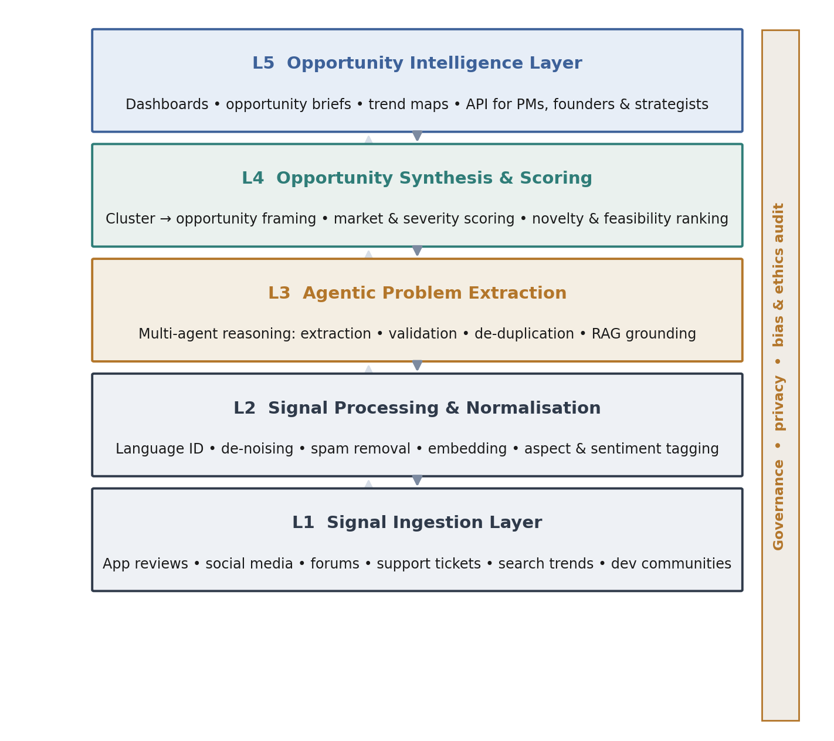
Fig. 2 The five-layer OpportunityOS reference architecture with a cross-cutting governance rail.

4.3 Signal Taxonomy
The ingestion layer normalises heterogeneous sources into a common signal schema. Table 2 summarises the principal source classes, the type of information each is richest in, and characteristic challenges. Diversity is deliberate: each source is biased, but their combination reduces blind spots, echoing evidence that app-store data alone is insufficient and benefits from complementary social signals [21].
Table 2 Taxonomy of user-signal sources ingested by OpportunityOS.
Source class | Richest in | Characteristic challenge
App / product reviews | Feature-level praise, bugs, requests | Rating bias; short, noisy text
Social media | Emerging sentiment, virality, context | Sarcasm; spam; volume
Developer & niche forums | Deep technical unmet needs | Jargon; small but high-signal
Support tickets | Concrete friction and failures | Private; access-restricted
Search & query trends | Latent demand and intent | Ambiguous intent; no sentiment
Q&A and community sites | Workarounds revealing gaps | Duplicated; uneven quality

5 Agentic Pipeline and Multi-Agent Orchestration

5.1 Agent Roles
The basic building block of L3-L4 is a set of specialized agents coordinated by an orchestrator who plans, routes, and maintains shared memory (Figure 3). Each agent has a limited scope of activity, is separately testable, and has its foundation on retrieving from a knowledge base containing information about markets, taxonomies, and discovered opportunities. The feedback loop sends results back to the planning step in accordance with the reasoning and acting design as well as multi-agent designs [36,38,41,42]. Table 3 lists the roles.
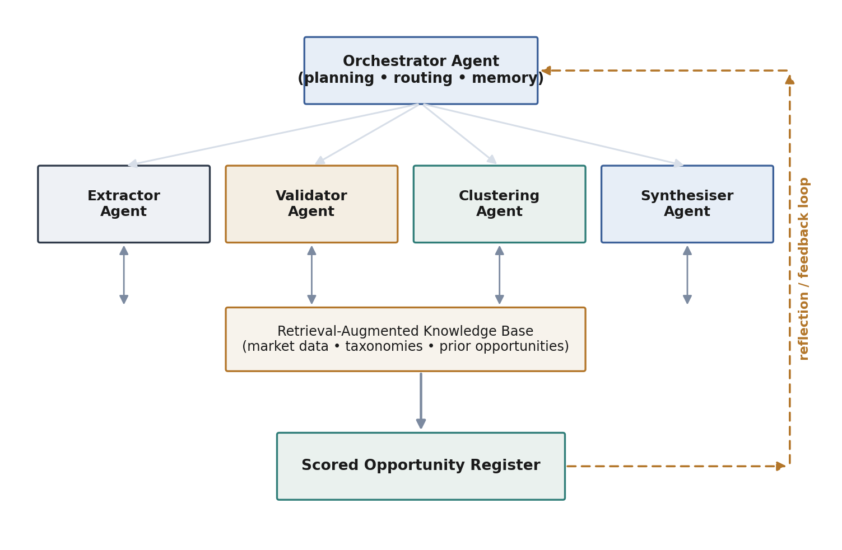
Fig. 3 Multi-agent orchestration: specialised agents grounded by a retrieval-augmented knowledge base, with a reflection loop.
Table 3 Specialised agents and their responsibilities.
Agent | Responsibility | Grounding / technique
Orchestrator | Plan, route tasks, hold shared memory | Planning + reflection [36]
Extractor | Extract candidate problems from tagged signals | ABSA + LLM extraction [8,32]
Validator | Filter spam, hallucinations, non-problems | RAG cross-check [37]
Clustering | Merge duplicates into coherent problem themes | Embeddings + topic models [27]
Synthesiser | Frame opportunities and compute scores | Retrieval + scoring model

5.2 From Signals to Problems
The Extractor translates the post-L2 tagged signal into problem statements that are linked to an aspect (for example, “onboarding–too many steps”), and the Validator discards spam, duplicate praise statements, and invalid statements lacking support in the retrieved evidence. The Clustering agent clusters the remaining statements into problem themes through density-based clustering on sentence embedding and additionally through topic modelling [27]. This process represents a progressively narrower filter (Fig. 4): out of billions of raw statements, only a few problem themes remain in each stage.
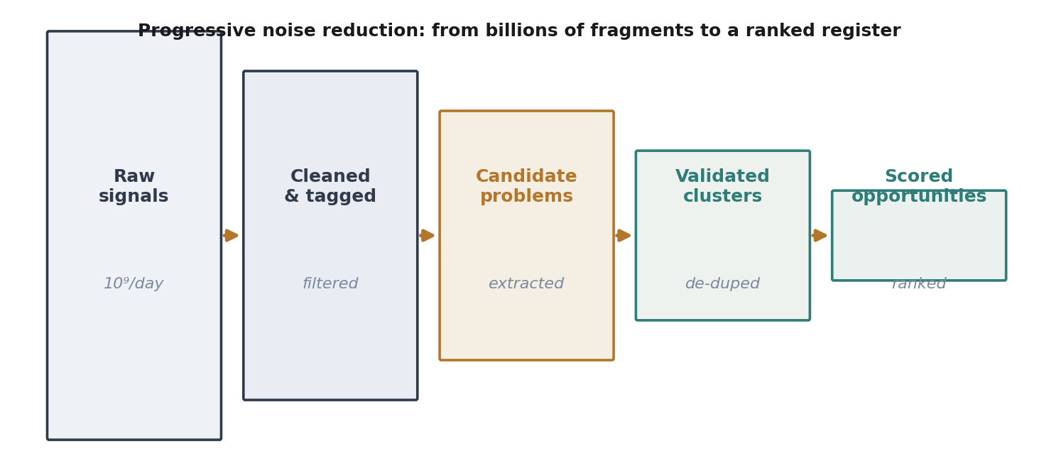
Fig. 4 The signal-to-opportunity funnel: progressive noise reduction from raw fragments to a ranked register.

5.3 Opportunity Synthesis and Scoring
For each problem theme, the Synthesiser frames an opportunity and computes a composite score across six dimensions: severity, prevalence, growth momentum, underservedness, feasibility and novelty. Growth momentum is a weak-signal indicator—the rate of change of a theme's frequency over time—so that rising but still-small problems are surfaced early [26]. Let each normalised dimension be d^{i} ∈ [0,1]. The opportunity score is the weighted sum
Score(o) = Σ wᵢ · dᵢ , with Σ wᵢ = 1 , wᵢ ≥ 0 ,
where the weights w^{i} are configurable to a decision-maker's strategy (e.g. a startup may up-weight novelty and underservedness; an incumbent may up-weight prevalence and feasibility). Because the score is explicit and every dimension is traceable to evidence, the ranking is auditable rather than a black box. Figure 5 illustrates two contrasting opportunity profiles: a high-priority opportunity that is severe, growing and underserved, versus a low-priority one that is prevalent but feasible-and-familiar with little novelty.
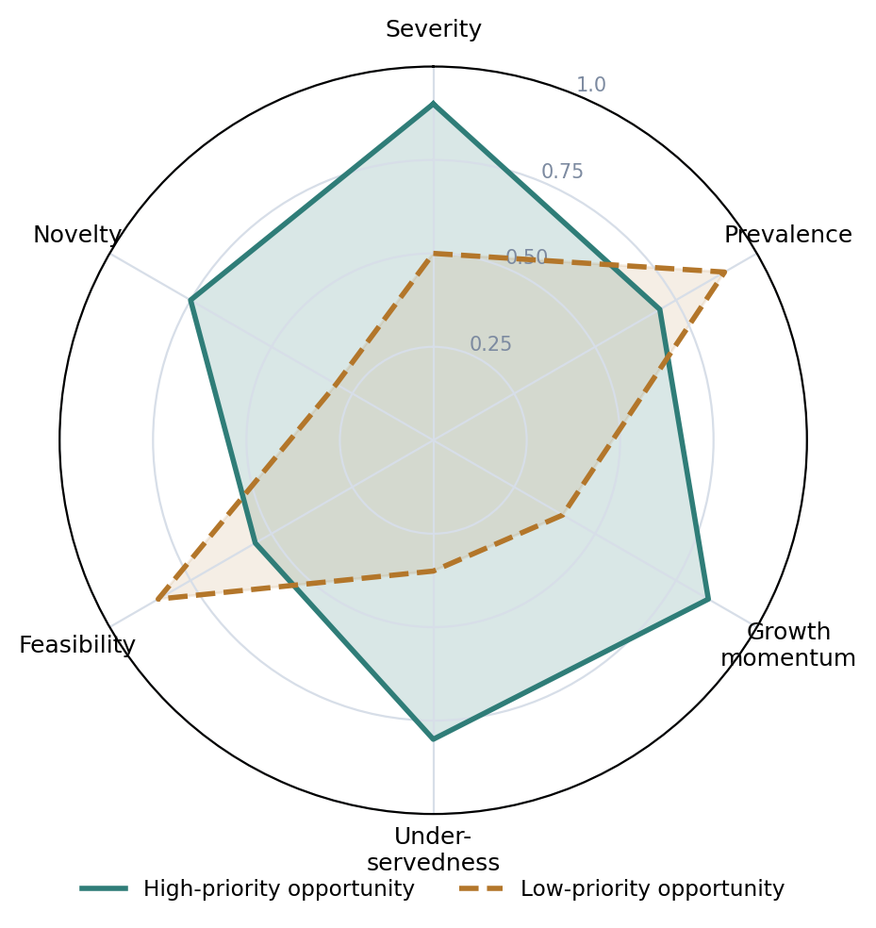
Fig. 5 Six-dimensional opportunity-scoring profiles for a high-priority and a low-priority opportunity.

6 Proposed Evaluation Methodology
Because ground-truth “worthwhile problems” are not directly observable, evaluation must be indirect and multi-pronged. We propose the metrics in Table 4. Discovery precision and expert concordance are assessed by expert panels blind-rating a sample of surfaced opportunities. Lead time is measured retrospectively: for opportunities that later became products or funded ventures, how early did the system surface the underlying problem relative to public consensus? Grounding fidelity reuses retrieval-augmented-generation evaluation practice to check that each opportunity is supported by cited signals [45,46]. Component metrics (ABSA F1, clustering coherence) validate the pipeline internally.
Table 4 Proposed evaluation metrics for OpportunityOS.
Metric | What it measures | Method
Discovery precision | Share of surfaced opportunities judged genuine | Blind expert panel
Expert concordance | Agreement with domain experts' rankings | Rank correlation
Lead time | How early a real opportunity is surfaced | Retrospective study
Grounding fidelity | Traceability of claims to signals | RAG-style faithfulness [45]
Component quality | ABSA F1, cluster coherence, dedup rate | Standard benchmarks [12]

7 Applications
Three application modes follow directly. For incumbents, OpportunityOS acts as an early-warning system that counters the disruption blind spot [1] by surfacing frustrations accumulating at the edges of a market. For founders, it inverts the usual solution-first workflow, offering a continuously updated map of underserved, growing problems and reducing the risk of building something unwanted [2]. For product managers, it complements existing review-mining tools [17,22] by ranking not just requested changes but latent, cross-source opportunities. In each case the human remains the decision-maker; the system widens and prioritises the option space.

8 Challenges, Limitations and Ethical Considerations
Several challenges temper the vision. Signal quality: discourse is noisy, sarcastic and unevenly distributed; sampling bias can privilege loud minorities, and ABSA still struggles with implicit aspects and domain shift [8,11]. Validation: distinguishing a genuine opportunity from a fad is intrinsically hard, and agentic pipelines can hallucinate or compound errors across steps, motivating strong grounding and reflection [37,41]. Evaluation: lead-time studies are retrospective and vulnerable to survivorship bias.
Ethics is a first-class matter, not a second thought. Ingestion of public dialogue leads to problems regarding privacy and consent, particularly with respect to support tickets and personally identifiable posts; the governance rail has to implement minimization, anonymization and purpose limitation. Since the outputs will influence decision-making around investments, any sort of amplification bias – which means that the problems of well-represented groups are surfaced and the problems of underserved communities are ignored – would simply reinforce inequality, thus bias auditing has to be implemented with regard to all the sources. Lastly, opportunities intelligence is a dual-use technology: just like the map can lead to helpful innovations, it could also lead to manipulative ones.

9 Conclusion and Future Work
It was asserted that in the current era where construction is cheap, the important scarce capability is that of knowing what needs to be constructed and we put forward the concept of OpportunityOS as an agentic-AI framework to automate the process of discovering opportunities from large-scale user signals. The architecture combines the concepts of aspect-based sentiment analysis, weak signal detection, retrieval augmented generation and multi agent orchestration in a five-layer architecture and formalizes opportunity scoring and a method of evaluation of the same.
The contribution is a transition from problem solving intelligence to problem discovery intelligence. The future direction of this research includes implementing the architecture empirically along with an expert annotated opportunity benchmark, longitudinal lead time analysis against real product launch and study on fairness aware sampling. The aim of this research is to develop a global opportunity intelligence capability which will help convert humanity’s digital conversations into the knowledge of what needs to be built next.
References
1. Christensen, C.M.: The Innovator's Dilemma: When New Technologies Cause Great Firms to Fail. Harvard Business Review Press, Boston (1997)
2. Ries, E.: The Lean Startup: How Today's Entrepreneurs Use Continuous Innovation to Create Radically Successful Businesses. Crown Business, New York (2011)
3. Schumpeter, J.A.: The Theory of Economic Development. Harvard University Press, Cambridge (1934)
4. Shane, S., Venkataraman, S.: The promise of entrepreneurship as a field of research. Acad. Manag. Rev. 25(1), 217–226 (2000)
5. Mary George, N., Parida, V., Lahti, T., Wincent, J.: A systematic literature review of entrepreneurial opportunity recognition: insights on influencing factors. Int. Entrep. Manag. J. 12(2), 309–350 (2016). https://doi.org/10.1007/s11365-014-0347-y
6. Hu, M., Liu, B.: Mining and summarizing customer reviews. In: Proceedings of the 10th ACM SIGKDD International Conference on Knowledge Discovery and Data Mining, pp. 168–177. ACM, Seattle (2004)
7. Pang, B., Lee, L.: Opinion mining and sentiment analysis. Found. Trends Inf. Retr. 2(1–2), 1–135 (2008)
8. Hua, Y.C., Denny, P., Wicker, J., Taskova, K.: A systematic review of aspect-based sentiment analysis: domains, methods and trends. Artif. Intell. Rev. 57(11), 296 (2024). https://doi.org/10.1007/s10462-024-10906-z
9. Wankhade, M., Rao, A.C.S., Kulkarni, C.: A survey on sentiment analysis methods, applications, and challenges. Artif. Intell. Rev. 55(7), 5731–5780 (2022). https://doi.org/10.1007/s10462-022-10144-1
10. Liu, H., Chatterjee, I., Zhou, M., Lu, X.S., Abusorrah, A.: Aspect-based sentiment analysis: a survey of deep learning methods. IEEE Trans. Comput. Soc. Syst. 7(6), 1358–1375 (2020)
11. Nazir, A., Rao, Y., Wu, L., Sun, L.: Issues and challenges of aspect-based sentiment analysis: a comprehensive survey. IEEE Trans. Affect. Comput. 13(2), 845–863 (2022)
12. Zhang, W., Li, X., Deng, Y., Bing, L., Lam, W.: A survey on aspect-based sentiment analysis: tasks, methods, and challenges. IEEE Trans. Knowl. Data Eng. 35(11), 11019–11038 (2022)
13. Pontiki, M., Galanis, D., Pavlopoulos, J., Papageorgiou, H., Androutsopoulos, I., Manandhar, S.: SemEval-2014 Task 4: aspect based sentiment analysis. In: Proceedings of the 8th International Workshop on Semantic Evaluation (SemEval 2014), pp. 27–35. ACL, Dublin (2014)
14. Maalej, W., Kurtanović, Z., Nabil, H., Stanik, C.: On the automatic classification of app reviews. Requir. Eng. 21(3), 311–331 (2016). https://doi.org/10.1007/s00766-016-0251-9
15. Maalej, W., Nabil, H.: Bug report, feature request, or simply praise? On automatically classifying app reviews. In: 23rd IEEE International Requirements Engineering Conference (RE), pp. 116–125. IEEE (2015)
16. Guzman, E., Maalej, W.: How do users like this feature? A fine grained sentiment analysis of app reviews. In: 22nd IEEE International Requirements Engineering Conference (RE), pp. 153–162. IEEE (2014)
17. Martin, W., Sarro, F., Jia, Y., Zhang, Y., Harman, M.: A survey of app store analysis for software engineering. IEEE Trans. Softw. Eng. 43(9), 817–847 (2017)
18. Chen, N., Lin, J., Hoi, S.C.H., Xiao, X., Zhang, B.: AR-Miner: mining informative reviews for developers from mobile app marketplace. In: Proceedings of the 36th International Conference on Software Engineering (ICSE), pp. 767–778. ACM (2014)
19. Iacob, C., Harrison, R.: Retrieving and analyzing mobile apps feature requests from online reviews. In: 10th Working Conference on Mining Software Repositories (MSR), pp. 41–44. IEEE (2013)
20. Harman, M., Jia, Y., Zhang, Y.: App store mining and analysis: MSR for app stores. In: 9th IEEE Working Conference on Mining Software Repositories (MSR), pp. 108–111. IEEE (2012)
21. Fu, B., Lin, J., Li, L., Faloutsos, C., Hong, J., Sadeh, N.: Why people hate your app: making sense of user feedback in a mobile app store. In: Proceedings of the 19th ACM SIGKDD International Conference on Knowledge Discovery and Data Mining, pp. 1276–1284. ACM (2013)
22. Panichella, S., Di Sorbo, A., Guzman, E., Visaggio, C.A., Canfora, G., Gall, H.C.: How can I improve my app? Classifying user reviews for software maintenance and evolution. In: IEEE International Conference on Software Maintenance and Evolution (ICSME), pp. 281–290. IEEE (2015)
23. Di Sorbo, A., Panichella, S., Alexandru, C.V., Shimagaki, J., Visaggio, C.A., Canfora, G., Gall, H.C.: What would users change in my app? Summarizing app reviews for recommending software changes. In: Proceedings of the 24th ACM SIGSOFT International Symposium on Foundations of Software Engineering (FSE), pp. 499–510. ACM (2016)
24. Guzman, E., El-Haliby, M., Bruegge, B.: Ensemble methods for app review classification: an approach for software evolution. In: 30th IEEE/ACM International Conference on Automated Software Engineering (ASE), pp. 771–776. IEEE (2015)
25. Genc-Nayebi, N., Abran, A.: A systematic literature review: opinion mining studies from mobile app store user reviews. J. Syst. Softw. 125, 207–219 (2017)
26. Kontostathis, A., Galitsky, L.M., Pottenger, W.M., Roy, S., Phelps, D.J.: A survey of emerging trend detection in textual data mining. In: Survey of Text Mining, pp. 185–224. Springer, New York (2004). https://doi.org/10.1007/978-1-4757-4305-0_9
27. Blei, D.M., Ng, A.Y., Jordan, M.I.: Latent Dirichlet Allocation. J. Mach. Learn. Res. 3, 993–1022 (2003)
28. Chen, H., Chiang, R.H.L., Storey, V.C.: Business intelligence and analytics: from big data to big impact. MIS Q. 36(4), 1165–1188 (2012)
29. Kaplan, A.M., Haenlein, M.: Users of the world, unite! The challenges and opportunities of social media. Bus. Horiz. 53(1), 59–68 (2010)
30. Vaswani, A., Shazeer, N., Parmar, N., Uszkoreit, J., Jones, L., Gomez, A.N., Kaiser, Ł., Polosukhin, I.: Attention is all you need. In: Advances in Neural Information Processing Systems, vol. 30, pp. 5998–6008 (2017)
31. Devlin, J., Chang, M.W., Lee, K., Toutanova, K.: BERT: pre-training of deep bidirectional transformers for language understanding. In: Proceedings of NAACL-HLT 2019, pp. 4171–4186. ACL (2019)
32. Brown, T.B., Mann, B., Ryder, N., et al.: Language models are few-shot learners. In: Advances in Neural Information Processing Systems, vol. 33, pp. 1877–1901 (2020)
33. Lewis, M., Liu, Y., Goyal, N., Ghazvininejad, M., Mohamed, A., Levy, O., Stoyanov, V., Zettlemoyer, L.: BART: denoising sequence-to-sequence pre-training for natural language generation, translation, and comprehension. In: Proceedings of the 58th Annual Meeting of the ACL, pp. 7871–7880 (2020)
34. Raffel, C., Shazeer, N., Roberts, A., Lee, K., Narang, S., Matena, M., Zhou, Y., Li, W., Liu, P.J.: Exploring the limits of transfer learning with a unified text-to-text transformer. J. Mach. Learn. Res. 21(140), 1–67 (2020)
35. Wei, J., Wang, X., Schuurmans, D., Bosma, M., Ichter, B., Xia, F., Chi, E., Le, Q., Zhou, D.: Chain-of-thought prompting elicits reasoning in large language models. In: Advances in Neural Information Processing Systems, vol. 35 (2022)
36. Yao, S., Zhao, J., Yu, D., Du, N., Shafran, I., Narasimhan, K., Cao, Y.: ReAct: synergizing reasoning and acting in language models. In: International Conference on Learning Representations (ICLR) (2023)
37. Lewis, P., Perez, E., Piktus, A., Petroni, F., Karpukhin, V., Goyal, N., Küttler, H., Lewis, M., Yih, W., Rocktäschel, T., Riedel, S., Kiela, D.: Retrieval-augmented generation for knowledge-intensive NLP tasks. In: Advances in Neural Information Processing Systems, vol. 33, pp. 9459–9474 (2020)
38. Wang, L., Ma, C., Feng, X., Zhang, Z., Yang, H., Zhang, J., Chen, Z., Tang, J., Chen, X., Lin, Y., et al.: A survey on large language model based autonomous agents. Front. Comput. Sci. 18(6), 186345 (2024). https://doi.org/10.1007/s11704-024-40231-1
39. Xi, Z., Chen, W., Guo, X., et al.: The rise and potential of large language model based agents: a survey. Sci. China Inf. Sci. 68(2), 121101 (2025)
40. Guo, T., Chen, X., Wang, Y., Chang, R., Pei, S., Chawla, N.V., Wiest, O., Zhang, X.: Large language model based multi-agents: a survey of progress and challenges. In: Proceedings of the 33rd International Joint Conference on Artificial Intelligence (IJCAI), pp. 8048–8057 (2024)
41. Hong, S., Zheng, X., Chen, J., et al.: MetaGPT: meta programming for a multi-agent collaborative framework. In: International Conference on Learning Representations (ICLR) (2024)
42. Wu, Q., Bansal, G., Zhang, J., Wu, Y., Li, B., Zhu, E., Jiang, L., Zhang, X., Zhang, S., Liu, J., Awadallah, A.H., White, R.W., Burger, D., Wang, C.: AutoGen: enabling next-gen LLM applications via multi-agent conversation. arXiv:2308.08155 (2023)
43. Park, J.S., O'Brien, J.C., Cai, C.J., Morris, M.R., Liang, P., Bernstein, M.S.: Generative agents: interactive simulacra of human behavior. In: Proceedings of the 36th ACM Symposium on User Interface Software and Technology (UIST) (2023)
44. Gao, Y., Xiong, Y., Gao, X., Jia, K., Pan, J., Bi, Y., Dai, Y., Sun, J., Wang, H.: Retrieval-augmented generation for large language models: a survey. arXiv:2312.10997 (2023)
45. Yu, H., Gan, A., Zhang, K., Tong, S., Liu, Q., Liu, Z.: Evaluation of retrieval-augmented generation: a survey. In: Big Data (BigData 2024). Communications in Computer and Information Science, vol. 2301, pp. 102–120. Springer, Singapore (2025). https://doi.org/10.1007/978-981-96-1024-2_8
46. Guo, J., Yang, H., Liu, Q.: A survey on retrieval-augmented generation technology in large language models. In: Computational Linguistics and Natural Language Processing (CLNLP 2025). Communications in Computer and Information Science, vol. 2775. Springer, Singapore (2026). https://doi.org/10.1007/978-981-95-4788-3_23
47. Shane, S.: Prior knowledge and the discovery of entrepreneurial opportunities. Organ. Sci. 11(4), 448–469 (2000)
48. Baron, R.A.: Opportunity recognition as pattern recognition: how entrepreneurs “connect the dots” to identify new business opportunities. Acad. Manag. Perspect. 20(1), 104–119 (2006)
49. Kirzner, I.M.: Competition and Entrepreneurship. University of Chicago Press, Chicago (1973)
50. Rai, A.: Explainable AI: from black box to glass box. J. Acad. Mark. Sci. 48, 137–141 (2020)

